ELLE PARKER
Character Profile Worksheet
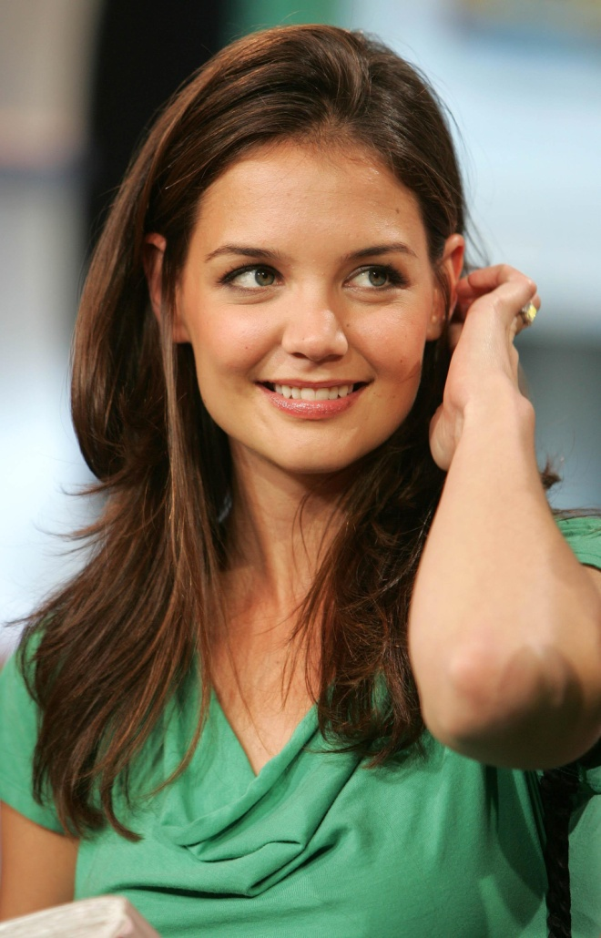
Basic Statistics
Name: Eleanor ‘Elle’ Parker
Age: 28
Nationality: British
Socio-economic Level as a child: Middle class
Socio-economic Level as an adult: Middle-Lower class
Hometown: London
Current Residence: London
Occupation: Public Relations Administrator
Income: None, but has her inheritance in her savings account.
Talents/Skills: Organisation, information retention, thinking on her feet, independence – although she used to fall in love too much.
Birth order: Has an older brother – Phillip, 33 years old.
Siblings (describe relationship): Distant. Phillip is a lawyer, married, has two children – Alice and Rodney. Married to a compulsive controlling witch.
Spouse (describe relationship): No spouse.
Children (describe relationship): No children.
Grandparents (describe relationship): Was good before they died. She misses them. She always felt that they never judged her in her life’s choices, and always encouraged her to do whatever she wanted.
Grandchildren (describe relationship): N/A
Significant Others (describe relationship): N/A
Relationship skills: A little shy, and tends to fall in love too easily. Once she falls in love, she finds that she loses her independence, and dedicates herself to her man. She knows that she has to stop doing this, but the fact that she feels she ‘punches above her weight’ lessens her self esteem.
Physical Characteristics:
Height: 5.8
Weight: 60 kilos
Race: Caucasian
Eye Color: Blue
Hair Color: Brown
Glasses or contact lenses? Glasses, and contacts. Glasses when she is at home, and contacts when she leaves the house. Lately she’s been wearing her glasses a lot more – hiding behind them after her last breakup with Alex.
Skin color: Fair, but she does tend to tan up a bit when she is out in the sun. Not that her skin ever sees the sun, one, because she lives in England, and two, because she works in a stuffy office under neon lights all day.
Shape of Face: Square/Oval
Distinguishing features: Her smile, and the way that her eyes light up with she’s happy or excited about something.
How does he/she dress? Conservatively. She would like to be snazzy and dress like some of the people she knows, but doesn’t think that she could ever pull it off with the same class that they do.
Mannerisms: Bites her fingernails, plays with her hair when she’s nervous, moves her foot or taps her finger to the beat of music.
Habits: (smoking, drinking etc.) Smokes when she has been drinking too much.
Health: Excellent, she loves to run in the mornings, but would never admit it to anyone else in the world. Doesn’t ever want to join a gym because she is too self conscious.
Hobbies: Reading, running, cross-stitch when she’s at home by herself, keeping her house to an immaculate standard and organized, relaxing, socialist with people she knows well, movies, painting or drawing, walking the beaches to de-stress, music. Music is one of the passions of her life. She loves driving her car, as it feels like it gives her independence (Silver VW Golf 2007).
Favorite Sayings: Woopsie-daisy, bugger, …………………………
Speech patterns: Only swears when she is drunk,
Disabilities: Eyesight is hopeless.
Style (Elegant, shabby etc.): Average.
Greatest flaw: Falling in love. Shyness.
Best quality: Selfless, loyal, and patient.
Intellectual/Mental/Personality Attributes and Attitudes
Educational Background: A Grade geek student. Went to Oxford university to study political science, but then couldn’t get a job with her degree. Hence why she went into administration.
Intelligence Level: Very bright.
Any Mental Illnesses? N/A
Learning Experiences: During the course of the book she will come to realise her own beauty and gradually gain confidence. She will also fall in love for all the right reasons, even though at the start of the book she will be defiant not to fall in love with anyone ever again.
Character's short-term goals in life: To get another job that she won’t be fired from. To pay off her adorable car.
Character's long-term goals in life: To be happy, and to eventually get married, have kids, all that jazz.
How does Character see himself/herself? Focused, (was) on track, someone who minds her own business, a little lonely, all round good person.
How does Character believe he/she is perceived by others? A bit of a pushover, geeky, quiet, antisocial,
How self-confident is the character? Confidence is bad.
Does the character seem ruled by emotion or logic or some combination thereof? She is ruled by both. Logic when it involves normal every day life and work, but emotion when it comes to matters of the heart.
What would most embarrass this character? Being centre of attention, blind date, put on the spot, having attention from men.
Emotional Characteristics
Strengths/Weaknesses: Patient, loyal, happy in her own company most of the time. Weakness - sad that she can’t find anyone to love her the way she loves them.
Introvert or Extrovert? Introvert.
How does the character deal with anger? Not well. She doesn’t like to show her anger in front of anyone else, but instead recedes into her more reclusive self.
With sadness? She obsesses about the reasons why things happen. Analyses over everything, and then throws herself into herself even more. She’s not depressed, just prefers to deal with things by herself.
With conflict? She hides from it.
With change? Okay, but it does take her time with get used to things.
With loss? Elle accepts that loss is a part of life. She misses those that have gone, but prefers to keep her fond memories of them, and generally creates something in loving memory of them so that they can remain close to her heart always.
What does the character want out of life? She wants to be happy, but she also wants someone to share her life with.
What would the character like to change in his/her life? A lot of things, but mainly her self esteem and confidence.
What motivates this character? Respect, acknowledgement.
What frightens this character? Losing those she loves.
What makes this character happy? Falling in love with someone new and unexplored.
Is the character judgmental of others? Not unless they are beautiful, then she thinks that they are not as intelligent as her. However, she would never say anything about this to anyone ever. She does not like her sister in law.
Is the character generous or stingy? Generous.
Is the character generally polite or rude? Polite
Spiritual Characteristics
Does the character believe in God? Atheist.
What are the character's spiritual beliefs? She has her own moral code that she lives by.
Is religion or spirituality a part of this character's life? Not really.
If so, what role does it play?
How the Character is Involved in the Story
Character's role in the novel: Heroine
Scene where character first appears: First.
Relationships with other characters: Rykeir
1. Character's Name: -- (Describe relationship with this character and changes to relationship over the course of the novel).
2. Character's Name: -- (Describe relationship with this character and changes to relationship over the course of the novel).
3. Character's Name: -- (Describe relationship with this character and changes to relationship over the course of the novel).
4. Character's Name: -- (Describe relationship with this character and changes to relationship over the course of the novel).
How character is different at the end of the novel from when the novel began:
At the beginning, Elle is tired, reclusive, sad by the loss of her job. She would like to find something else, but also wants to take her time to make sure that she gets the right one. Now is the time where she is re-evaluating her life.
Her heart is broken, again. She tends to fall in love easily, and finds that her heart keeps getting broken. As part of the re-evaluation, she makes the decision not to fall in love easily anymore. She is sick of her heart being trampled on.
When she meets Rykeir Bontecou, though she finds him attractive (who wouldn’t) she denies him the opportunity. Again, it is punching above her weight. He is attractive, she feels she isn’t. She mistakes him for being arrogant, and presumptuous, when in fact he is genuinely attracted to her.
As the danger increases, she finds herself turning to Rykeir more and more. Rykeir is more than happy to help out, thus opening her heart to him little by little.
Rykeir challenges her intellectually, and eventually she starts to see herself through his eyes more and more. Her confidence rises with each challenging situation.
Additional Notes on This Character:
Elle wants to be happy in life. Yes, she wants to find her significant other, but she wants to happy within herself first.

